TDS – Plzen
Description
Plzen is a high quality Active Dry Brewing Yeast, ideal for crafting a wide range of traditionally brewed lager beers.
Benefits
- Well-suited for brewing a wide range of traditional European Lager styles, including German and Bohemian Pilsner, American Pilsner, Maibock, Doppelbock, Oktoberfest, and Marzen
- 74 - 81% Attenuation
- High flocculation
- 9 - 11% ABV alcohol tolerance
- Very fast fermentation rate
- Very good foam stability
- Fast Diacetyl reduction
- Low Acetaldehyde
- POF negative
Principle
Plzen yeast is a bottom fermenting yeast designed to embody the crisp, clean character synonymous with traditional Lager beers. Plzen yeast will produce a pure flavour profile with a fine, complex, subtle, fruity aroma and mild palate – yielding a beer with a very clean and crisp aroma, true to lager/pilsner style beers. This yeast strain is highly flocculent, giving crisp, brilliant, bright beer.
Application and rates of use

Pitching rate: 100-200 g/hL. The pitching rate varies with original gravity of the wort as well as brewing conditions.
When to Use:
This yeast can be pitched directly. If rehydration is preferred, follow these steps:
- Prepare the rehydration medium: 10 times the weight of yeast (5 litres for a 500g package), using either sterile wort (<5° Plato) or sterile water at 28 - 35°C (82 - 95°F). Optimum 30°C (86°F). We recommend against using demineralised water.
- Open the 500g package with sterile scissors and sprinkle on the surface to avoid clumping.
- Gently stir before leaving for 15 – 20 minutes, the slow rehydration will allow yeast membranes to reform.
- Adjust the temperature of the rehydrated yeast to within 5°C (9°F) of the pitching wort. Never subject the yeast to temperature shock.
- Gently stir and leave for a further 5 – 10 minutes.
- Stir well and pour into the wort to start fermentation. Use the rehydrated yeast within 30 minutes of rehydration.
Optimal fermentation temperature: 12-15°C | 53-59°F. For optimal results do not ferment at temperatures lower than 12°C.
Typical Analysis at packaging:
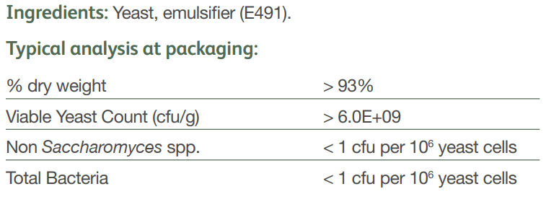
Storage and shelf life info can be copied and pasted from sales sheet

