TDS – Chico Maestro
Description
Chico Maestro is a high quality Active Dry Brewing Yeast that brings forth the quintessential characteristics of American Ales, with a focus on crispness, clean fermentation, and a pronounced hop-forward aroma.
Benefits
- Well-suited for brewing a wide range of hop-forward styles like West Coast IPA, American Pale Ale, Double IPA, American Amber Ale or California Common
- 76 - 82% Attenuation
- High flocculation
- 9 - 11% ABV alcohol tolerance
- Very fast fermentation rate
- Excellent foam stability
- Low Acetaldehyde
- POF negative
Principle
The Chico Maestro produces well-balanced beers characterised by low diacetyl levels and a clean profile, featuring very subtle banana-like aromas and floral hints that allow the grain and hop flavours to shine through.
Application and rates of use

Pitching rate: 50-100g/hL. The pitching rate varies with original gravity of the wort as well as brewing conditions.
When to Use:
This yeast can be pitched directly. If rehydration is preferred, follow these steps:
- Prepare the rehydration medium: 10 times the weight of yeast (5 litres for a 500g package), using either sterile wort (<5° Plato) or sterile water at 28 - 35°C (82 - 95°F). Optimum 30°C (86°F). We recommend against using demineralised water.
- Open the 500g package with sterile scissors and sprinkle on the surface to avoid clumping.
- Gently stir before leaving for 15 – 20 minutes, the slow rehydration will allow yeast membranes to reform.
- Adjust the temperature of the rehydrated yeast to within 5°C (9°F) of the pitching wort. Never subject the yeast to temperature shock.
- Gently stir and leave for a further 5 – 10 minutes.
- Stir well and pour into the wort to start fermentation. Use the rehydrated yeast within 30 minutes of rehydration.
Optimal fermentation temperature: 16 - 21°C | 60 – 70°F
Typical Analysis at packaging:
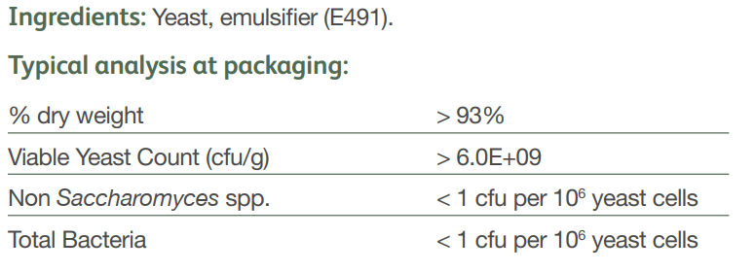
Storage and shelf life info can be copied and pasted from sales sheet

