TDS – Blank Canvas
Description
Blank Canvas is a high quality Active Dry Brewing Yeast that can be used in a wide variety of traditionally brewed English Ale styles.
Benefits
- Well-suited for brewing a wide range of traditional English Ale styles, including Bitters, Milds, Porters, Stouts, and Barley Wine
- 72 - 78% Attenuation
• Very high flocculation
• 9 - 11% ABV alcohol tolerance
• Very fast fermentation rate
• Excellent foam stability
• POF negative
• High cell viability throughout fermentation
• Low Acetaldehyde formation

Principle
- This yeast produces neutral, subtly fruity, and estery brews with a crisp, mildly sweet aftertaste, showcasing the delightful interplay of malt and hop essence, particularly when fermented at 18°C. Well-suited for brewing a wide range of traditional English Ale styles, including Bitters, Milds, Porters, Stouts, and Barley Wine. Blank Canvas’ high flocculation behaviour makes it an ideal yeast choice for cask conditioned beers.

Application and rates of use

Pitching rate: 50-100g/hL. The pitching rate varies with original gravity of the wort as well as brewing conditions.
When to Use:
This yeast can be pitched directly. If rehydration is preferred, follow these steps:
- Prepare the rehydration medium: 10 times the weight of yeast (5 litres for a 500g package), using either sterile wort (<5° Plato) or sterile water at 28 - 35°C (82 - 95°F). Optimum 30°C (86°F). We recommend against using demineralised water.
- Open the 500g package with sterile scissors and sprinkle on the surface to avoid clumping.
- Gently stir before leaving for 15 – 20 minutes, the slow rehydration will allow yeast membranes to reform.
- Adjust the temperature of the rehydrated yeast to within 5°C (9°F) of the pitching wort. Never subject the yeast to temperature shock.
- Gently stir and leave for a further 5 – 10 minutes.
- Stir well and pour into the wort to start fermentation. Use the rehydrated yeast within 30 minutes of rehydration.
Optimal fermentation temperature: 18 - 22°C | 64 – 72°F
Typical Analysis at packaging:
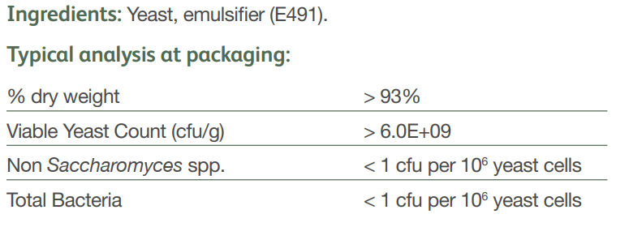
Storage and shelf life info can be copied and pasted from sales sheet

